長谷大樓

德勒斯登

InterContinental Kaohsiung
高雄洲際飯店
南高雄的天空
South Kaohsiung Skyline

85大樓 壽山 柴山

高醫啟川大樓
漢神百貨 國硯
夢萊茵

台灣神經血管外科與介入治療醫學會2026年會員大會暨國際學術研討會
Taiwan Society for Neurovascular and Interventional Surgery 2026 Annual International Symposium
會議時間：2026年5月2日~3日
會議地點：高雄洲際酒店3樓大宴會廳 InterContinental Kaohsiung, 3F
2026.05.02 Saturday

Time Topic Speaker Modulator
10:00~10:20 Registration
10:20~10:30 Welcome 許世偉醫師 TSNIS 理事長
MeVO Thrombectomy: Evolution of Technique and Improved Aspiration

10:30~10:50
Dynamics- A Single-center Experience from EDAH 鄭秋詩醫師 義大醫院

Quantitative Evaluation of Cerebral Revasculization in Atherosclerotic
10:50~11:10 Arterial Occlusion: Impact of Low-Flow EC-IC Bypass
Contrast Encephalopathy related to Endovascular Intervention of
莊銘榮醫師 高雄長庚紀念醫院
歐長憲醫師

11:10~11:30

11:30~11:50
Intracranial Aneurysms 陳威良醫師 中國醫藥大學附設醫院
Exciting and Scary: An Imaginative Look at How AI will Reshape the
Workflow of Interventional Neurosurgery 蔡元雄教授 嘉義長庚紀念醫院
張哲肇醫師

11:50~12:00 Preparing Lunch Box
14:40~15:00 Break (Coffee, Tea C Snack)

崔源生醫師陳文賢醫師
賴彥君醫師 亞東紀念醫院
Sinus Preservation During Transarterial Embolization of the
Transverse/Sigmoid Sinus Dural Arteriovenous Fistulas
14:00~14:20
13:10~13:30 Q & A and Break
Lunch Symposium (1): New AHA Stroke Guidelines Update and A
12:10~12:40 Comprehensive View of RapidAI Imaging (RapidAI)
Danny Jiang
APAC Sales Director RapidAI, Singapore
蔡元雄醫師
Lunch Symposium (2): Treatment of Brain AVM using PHIL (Terumo
12:40~13:10 Neuro)
Jaturon Tantivatana M.D. Professor
Chulalongkorn University, Bangkok, Thailand
楊宜曉醫師

13:30~14:00
Special Lecture (1): Advanced Imaging and Endovascular Treatment of Spinal Shunt Disease
Yasunari Niimi, M.D. Professor
St. Luke’s International Hospital, Tokyo, Japan

14:20~14:40
Neurocognitive Phenotypes in Patients with Aggressive Dural Arteriovenous Fistulas: Angioarchitecture, Venous Hypertension, and Reversibility

蘇亦昌醫師 雙和醫院

15:00~15:30
Special Lecture (2): New Devices for Endovascular Treatment of Cerebral Aneurysm : Flow Diverter and Intravascular Flow Disruptor
Akio Hyodo, M.D. Professor
Kamagaya General Hospital, Chiba, Japan

15:30~15:50 Heal Technology for Intracranial Stent and Flow Diverter (Acandis)
黃浩輝教授 林口長庚紀念醫院
崔祐堃醫師

15:50~16:10
Exploring the New Space-seeking Coil for Intracranial Aneurysm Embolization (Wallaby Phenox)
Sumita Kazutaka, M.D. Professor
Institute of Science, Tokyo, Japan.
陳敬昌醫師


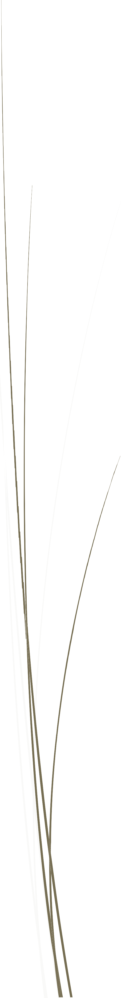
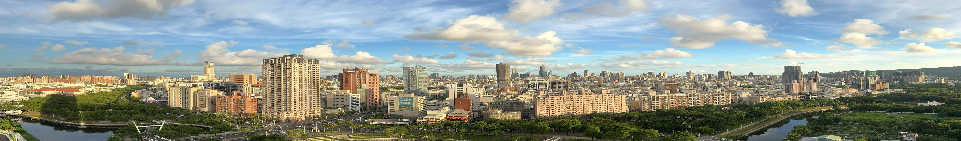
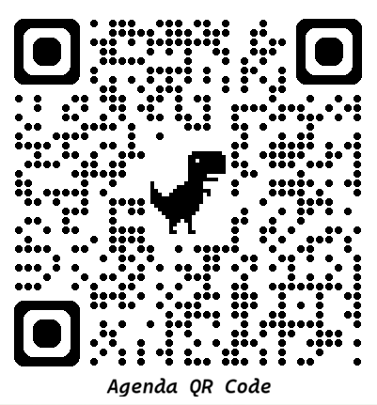
16:10~16:30 Giant Intracranial Aneurysms (Stryker)
Hae Woong Jeong, M.D., Ph.D. Professor
Busan Paik Hospital, Inje University, Busan, Korea
16:30~18:00 Self-exploring the Beautiful Kaohsiung Harbor
18:00~19:00 Member Congress C Dinner Banquet All Member C Honorable Guests
19:00~21:30 INR Cases Sharing and Discussion All Attendees 楊宜曉醫師

2026.05.03 Sunday
Time | Topic | Speaker | Modulator
09:10~09:30 | How to Safely Perform a Step-by-step Minimally Invasive Craniotomy for  Brain Aneurysm Clipping | 李崇新醫師 台中榮民總醫院 | 蘇亦昌醫師林彥亨醫師
09:30~09:50 | Predicting Recurrence of Blood Blister-like Aneurysm : the Importance of Aneurysmal Neck Area | 黃俊肇醫師 馬偕紀念醫院 | 蘇亦昌醫師林彥亨醫師
09:50~10:10 | The Utility of Stentriever as First-line to Treat an Embolic Event (Balt) | Yilmaz Onal M.D. Professor  University of Health Sciences, Fatih Sultan Mehmet Teaching and Research Hospital, Istanbul, Turkey | 蘇亦昌醫師林彥亨醫師
10:10~10:30 | Break (Coffee, Tea C Snack)
10:30~10:50 | Beyond the Trial: Refined Chronic SDH Treatment with MMA  Embolization – The Linko CGMH Experience | 陳敬昌醫師 林口長庚紀念醫院 | 李崇維醫師黃致遠醫師
10:50~11:20 | Special Lecture (3): Rescue Intracranial Stenting: Single Center Experience in Singapore | Kee Tze Phei, M.D. Professor  National Neuroscience Institute, Singapore | 李崇維醫師黃致遠醫師
11:20~11:50 | Special Lecture (4): Technical Tips of Endovascular Treatment of Cerebral aneurysm using Woven Endo Bridge | Akio Hyodo, M.D. Professor  Kamagaya General Hospital, Chiba, Japan | 李崇維醫師黃致遠醫師
11:50~12:00 | Preparing Lunch Box
12:00~12:30 | Lunch Symposium (3): Science-Based Aspiration Thrombectomy (Penumbra) | Chai Kobkitsuksakul M.D. Professor  Faculty of Medicine, Ramathibodi Hospital, Mahidol University, Bangkok, Thailand | 賴彥君醫師
12:30~13:00 | Lunch Symposium (4): Surpass Streamline to Evolve to Elite (Stryker) | Hae Woong Jeong, M.D., Ph.D. Professor  Busan Paik Hospital, Inje University, Busan, Korea | 林宛瑾醫師
13:00~13:20 | Q C A and Break
13:20~13:50 | Special lecture (5): Posterior Circulation Stroke: Endovascular Strategies from Basilar to Distal Occlusion (Penumbra) | Chai Kobkitsuksakul M.D. Professor  Faculty of Medicine, Ramathibodi Hospital, Mahidol University, Bangkok, Thailand | 許育弘醫師
13:50~14:10 | Dorsum Sella Sinus Dural Arteriovenous Fistulas | 鄭皓中醫師 臺大醫院
14:10~14:40 | Special Lecture (6): Flow Diverter Beyond the Proximal ICA (Balt) | Yilmaz Onal M.D. Professor  University of Health Sciences, Fatih Sultan Mehmet Teaching and Research Hospital, Istanbul, Turkey | 黃俊肇醫師
14:40~15:00 | Break (Coffee, Tea C Snack)
15:00~15:30 | Special Lecture (7): (Terumo Neuro) | Keun Young Park, M.D. Professor  Severance Hospital, Yonsei University, Soel, Korea
15:30~15:50 | NTUH Protocol of Transradial Approach | 陳國瑋醫師 臺大醫院 | 陳威良醫師
15:50~16:10 | Experience of Spinal Arteriovenous Fistulas at TCVGH | 陳文賢醫師 台中榮民總醫院 | 許斯凱醫師
16:10~16:30 | Evidence and Strategy for MeVO Thrombectomy in the Post-ESCAPE Era | 陳悅生醫師 高雄長庚紀念醫院
16:30~16:40 | Closing | 許世偉醫師 TSNIS 理事長

